Project by

  Charvee Saraiya B-220 70022000195

Shobhit Paliwal B-218 70022000189

Ankon Nandi B-219 70022000191

Hospital management system

* **PROJECT NAME: HOSPITAL MANAGEMENT SYSTEM**
* **Introduction :**

Our DBMS project is based on Hospital management.

It provides data like patient details, doctor details, billing details, medication details, test reports ,pharmacy store details of various hospitals.

All the useful information about all the hospitals can be found using this project.

The patient is assigned a unique patient id that helps access all their records.

Similarly doctors are assigned a unique doctor id by which their information can be stored in the database.

## Data Requirements:

#### Entity types

1. HOSPITAL

Every hospital has attributes,

* 1. **Hospital id which is unique and not null.**
  2. Hospital name which stores name of hospital and is not null.
  3. Address stores address of hospital which is not null.

1. Doc

tor

Every doctor has attributes,

* 1. **Doctor id which is unique and not null.**
  2. Name is a composite attribute of first name, second name and last name of doctor.
  3. Address stores address of doctor.
  4. Phone no.stores phone number of doctor.
  5. Speciality stores speciality of doctor and is not null .
  6. Paid_amount stores salary of doctor and is not null.
  7. Email stores email of doctor.

1. SUPERINTENDENT

Every visit detail has attributes,

* 1. U_id which is unique and not null.
  2. Name is a composite attribute of first name, second name and last name of superintendent.
  3. Address stores address of superintendent .
  4. Contact no. stores phone number of superintendent.
  5. Email stores email of superintendent.

1. MEDICINE

Medicine has attributes,

* 1. Medicine_name which is unique and not null.
  2. Cost stores cost of medicine.
  3. Stock gives stock of medicine.
  4. Company name gives name of company who developed medicine which is not null.

1. PATIENT

Patient has attributes,

* 1. Name is a composite attribute of first name, second name and last name of doctor which should not be null.
  2. Address stores address of patient which should not be null.
  3. Phone no. has phone no of patient.
  4. DOB for patient date of birth.
  5. Gender for storing character ‘m’ for male, ‘f’ for female.
  6. Patient_id which is unique and not null.
  7. Blood group which should not be null.
  8. Emergency phone number should not be null.
  9. Emergency name should not be null.
  10. Last_visit is derived attribute which can be derived from visit date and visit time attribute of visits relationship type.

**BILL**

Bill has attributes,

1. Bill_id which is unique and not null .
2. Patient id has data type varchar and it is a foreign key here which is a primary key in patient entity .
3. Total fees stores total bill to be paid by patient.
4. Due date is the last date to pay the bill.
5. Paid date has the date of last payment.
6. Paid_amount is the amount paid by patient.
7. Added_time is the time at which the bill was issued.
8. Due_amount is the derived attribute which is derived from paid amount and total fees.

#### Relationship types:

* 1. **Doctor works in hospital (1:N)**

A doctor can work in only one hospital and one hospital can have many doctors.

It is not necessary that doctor has to work in a hospital but hospital should have at least one doctor.

TOTAL PARTICIPATION OF HOSPITAL AND PARTIAL PARTICIPATION OF DOCTOR.

* 1. **Superintendent supervises hospital (1:1)**

A hospital can have exactly 1 superintendent and a superintendent should work in exactly 1 hospital.

TOTAL PARTICIPATION OF SUPERINTENDENT AND TOTAL PARTICIPATION OF HOSPITAL.

* 1. **Patient visits hospital (M:N)**

A patient can visit many hospitals and one hospital can be visited by many patients. TOTAL PARTICIPATION OF PATIENT AND PARTIAL PARTICIPATION OF HOSPITAL.

* 1. **Doctor performs tests on patient (M:N)**

A doctor may or may not do tests on many patients and a many doctors can perform tests on a patient

PARTIAL PARTICIPATION OF PATIENT AND PARTIAL PARTICIPATION OF DOCTOR.

* 1. **Patient pays bill (1:1)**

A patient has to may exactly 1 bill and exactly 1 bill is paid by patient. TOTAL PARTICIPATION OF PATIENT AND TOTAL PARTICIPATION OF BILL.

* 1. **Hospital generates bill (1:M)**

Hospital can generate many bills but a particular bill is generated by only one hospital.

TOTAL PARTICIPATION OF BILL AND PARTIAL PARTICIPATION OF HOSPITAL.

* **FUNCTIONAL REQUIREMENTS**
  + 1. **REMOVAL OF OLD DATA:**
       - * Delete Doctor Data Who Is Not Working In Any Hospital

I.E Hospital_Id=Null

* + - * + Delete Patient Data Who Has Not Visited The Hospital From Past 2 Years

After Updating The Paid_Amount In Bill If The Full Amount Is Paid Then That Bill Data Gets Deleted From Bill Table

* + - * + If no pharmacy sells a medicine then that medicine has to be deleted
    1. **MODIFICATION OF DATA:**
       1. Patient with patient id 105 paid 1000 RS amount for the treatment he received so update that amount in his bill details.
       2. Add a new column to bill table which has due amount and update it.
       3. Give a discount of 100 RS in total fees to all patients having blood group of O-
       4. Put a penalty on bills of a hospital whose due date is passed system date.
       5. After deleting the paid_amount in bill if the full amount is paid then that bill data gets deleted from bill table and gets stored in paid_bill table.
       6. When License no of pharmacy is changed then it needs to be updated in other tables i.e sells and
    2. **RETRIEVAL OF DATA:**
       1. Give hospital name and url . If url is null then show not present
       2. Give hospital id,name and email of superitendents . If email is not given then show null.
       3. Retrive medicine name and pharmacy selling in it with cost in increasing order
       4. Find doctor names who has average costs of tests on his / her patients >900
       5. Find patient names who pays higher than the average amount that patients pay to a hospital
       6. Retrive Pharmacy Name And License No Of Pharmacy Which Sells both two kind of medicines.
       7. Find Doctors who work in a particular hospital
       8. Retrive Hospital_Id And Cases Of Corona With Corona Cases>particular number.
       9. Find Hospitals Located at given location
       10. Find patient name who has done a particular test.
       11. Find patient name and contact no whose bill due date is a given date.
       12. Find number of patients visited at a hospital on a particular date.
       13. Get percentage of pharmacies who sell a particular medicine

## ER-DIAGRAM

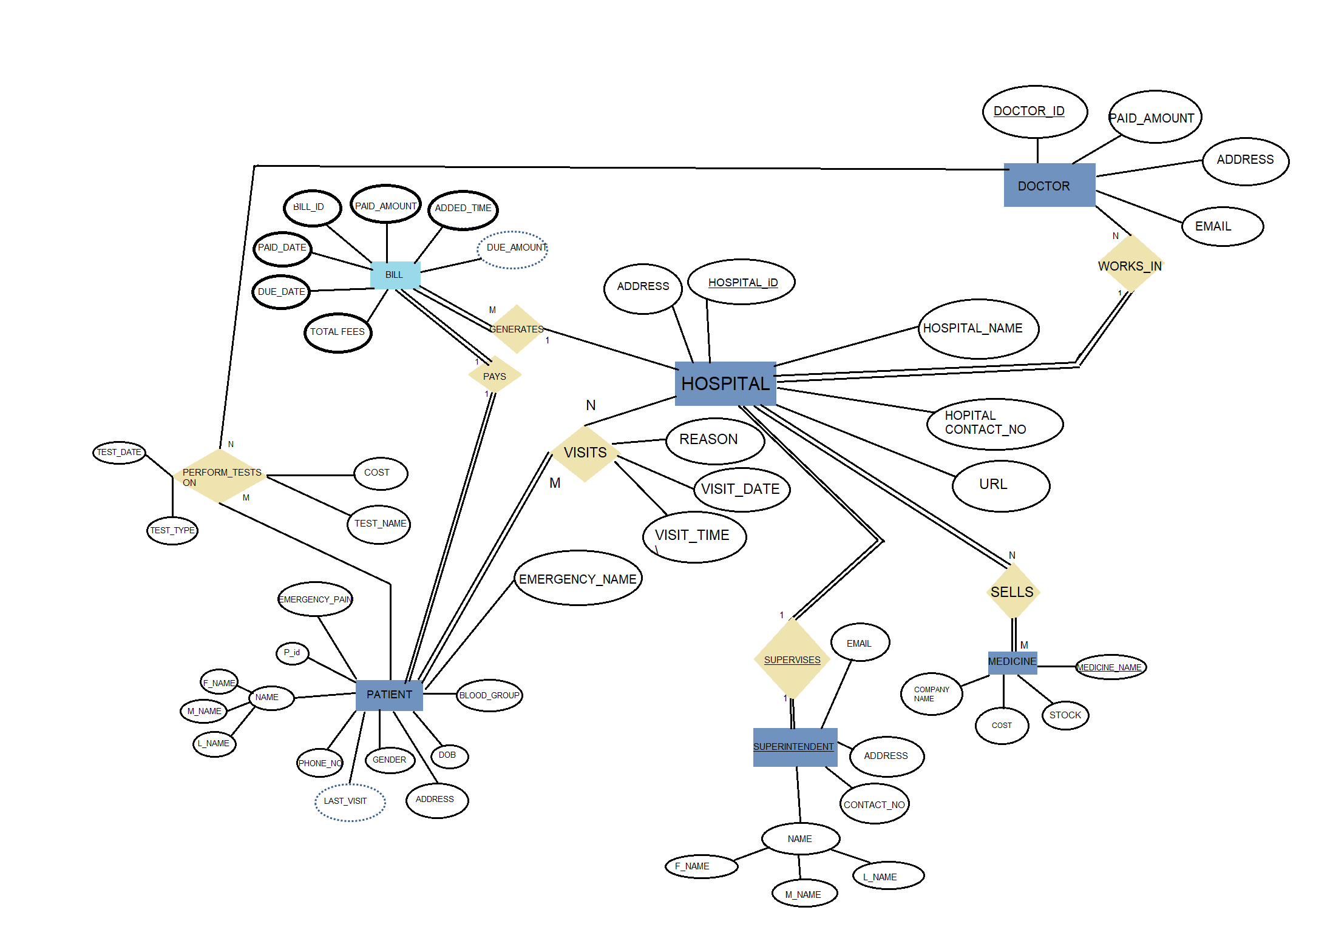

## RELATIONAL DATABASE SCHEMA DIAGRAM

1. **Convert the ER/EER diagram into a relational database schema diagram.**

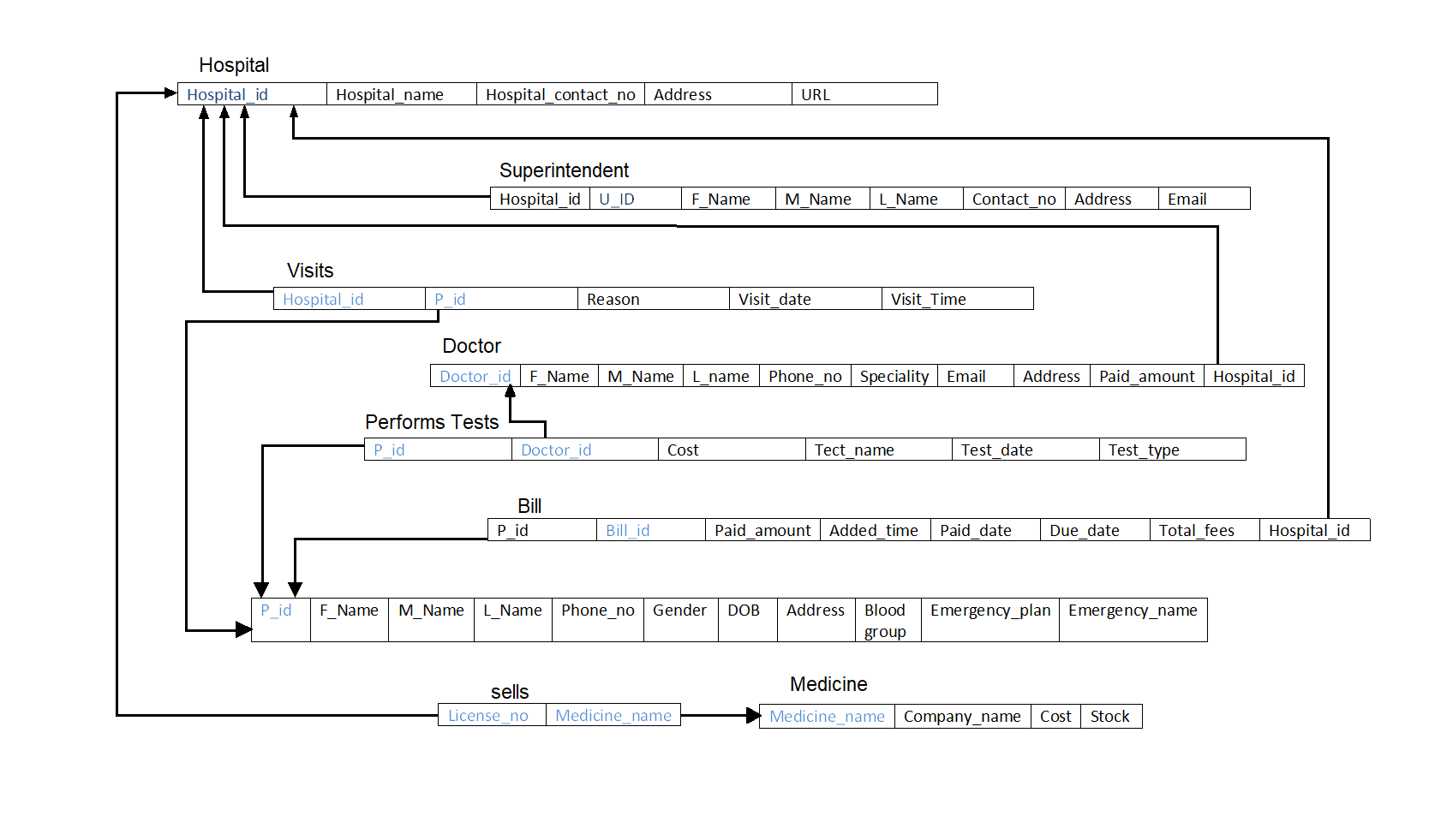

1. **(a) Implement the relational database schema incorporating appropriate (based on data requirements) integrity constraints. Each integrity constraint should be assigned a name.**

**CREATING TABLES**

* 1. **Hospital Table**
* create table hospital(

2 hospital_id varchar2(10) not null constraint hospital_pk primary key,

3 hospital_name varchar2(30) not null,

4 hospital_contact_no number(10) not null,

5 address varchar2(50) not null,

6 url varchar(20)

);

7 );

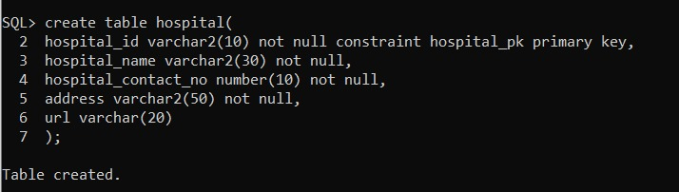

Desc hospital;

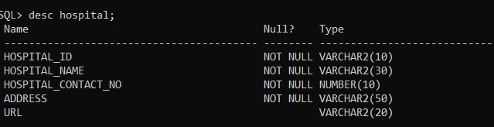

* 1. **Superitendent Table**

create table superitendent(

2 u_id number(3) not null constraints superintendent_pk primary key,

3 hospital_id varchar2(10) not null,

4 firstname varchar2(20) not null,

5 middlename varchar2(20) not null,

6 lastname varchar2(20) not null,

7 contact_no number(10) not null,

8 address varchar2(50) not null,

9 email varchar(20) not null

10 );

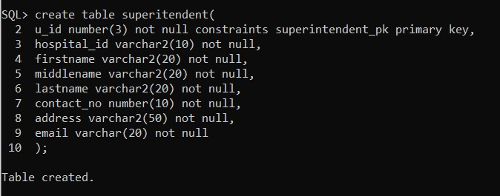

* **Desc Superitendent;**

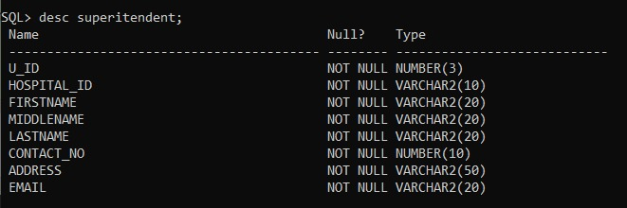

* **DOCTOR TABLE**

create table doctor(

2 doctor_id number(3) not null constraint doctor_pk primary key,

3 f_name varchar2(20) not null,

4 m_name varchar2(20) not null,

5 l_name varchar2(20) not null,

6 phone_no number(10) not null,

7 speciality varchar2(20) not null,

8 email varchar2(20),

9 address varchar2(20),

10 paid_amount number(5),

11 hospital_id varchar2(10) not null

12 );

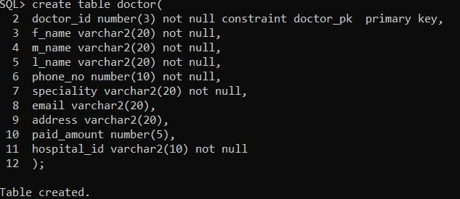

* **Desc Doctor-**

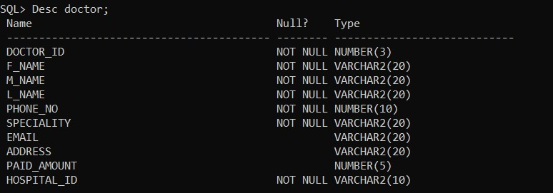

* **VISITS TABLE-**

create table visits(

2 hospital_id varchar2(10) not null,

3 p_id number(10) not null,

4 reason varchar2(50),

5 visit_date date,

6 visit_time timestamp(0),

7 constraint hospitalid_pid_pk PRIMARY KEY (hospital_id,p_id)

8 );

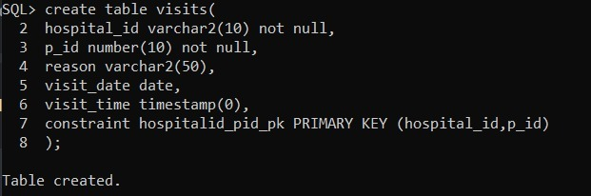

* **Desc visits-**

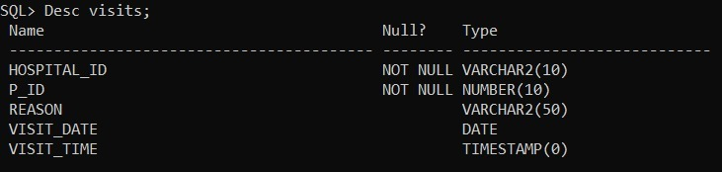

* **Performs Tests Table**

1. create table perform_tests(

p_id number(10) not null,

doctor_id number(3) not null,

hospital_id varchar2(10) not null,

cost number(10) not null,

test_name varchar(20) not null,

test_date date,

test_type varchar2(10) not null,

constraint ptests_hid_pid_pk primary key(hospital_id,p_id)

);



* **Desc Perform Test**-

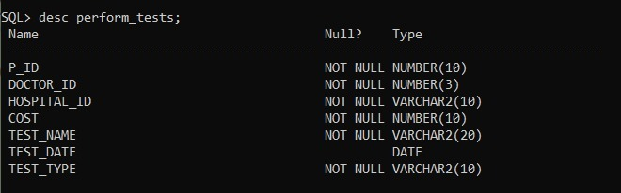

* **Patient table-**

create table patient(

2 patient_id number(10) constraint patient_pk primary key,

3 patient_first_name varchar2(20) not null,

4 patient_last_name varchar2(20)

5 ,

6 patient_middle_name varchar2(20),

7 phone_number number(10),

8 gender char(1),

9 DOB date,

10 address varchar2(100),

11 blood_group varchar2(3),

12 emergency_phone_no number(10) not null,

13 emergency_name char(20) not null

14 );

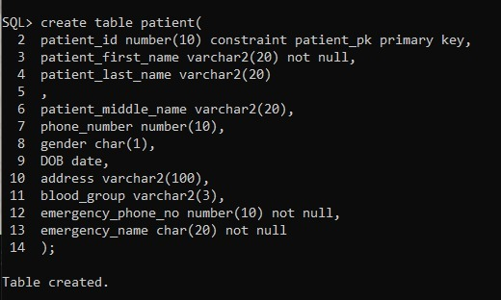

* **Desc Patient-**

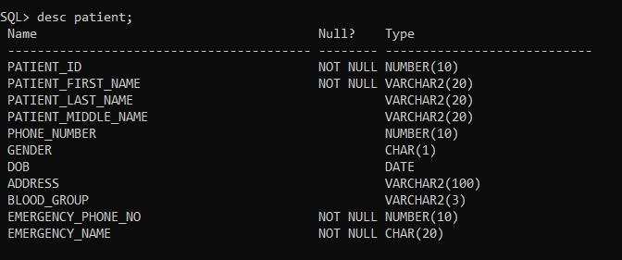

* **Bill table-**

create table bill(

2 bill_id number(10) constraint bill_pk primary key,

3 paid_amount number(10),

4 added_time timestamp(0),

5 paid_date date,

6 due_date date not null,

7 total_fees number(10) not null,

8 patient_id number(10) not null,

9 hospital_id varchar2(10) not null

10 );

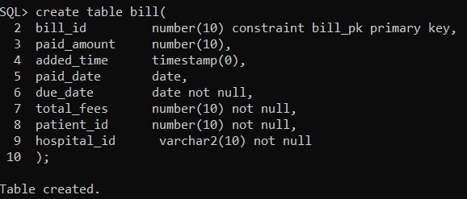

* **Desc bill table-**

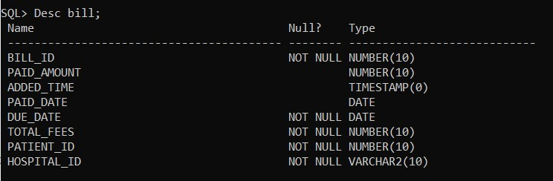

* **Sells table-**

create table sells(

2 medicine_name varchar2(20),

3 license_no number(10),

4 constraint sells_pk primary key (medicine_name, license_no)

5 );

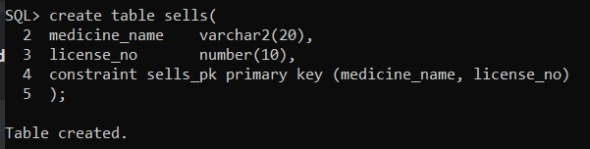

* **Desc sells table-**

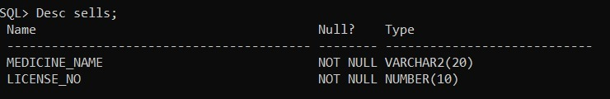

* **Medicine table-**

create table medicine(

2 medicine_name varchar2(20) constraint med_name_pk primary key,

3 company_name char(2) not null,

4 cost number(10) not null,

5 stock number(10)

6 );

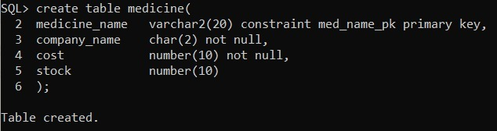

* **Desc medicine table-**

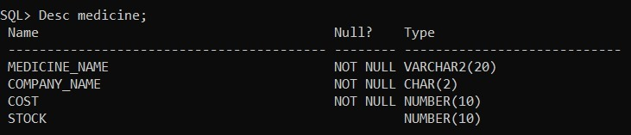

**Foreign Keys Constraints**

**Referencing to Hospital Table – 5 constraints**

alter table doctor add constraint doctor_hospitalid_fk foreign key(hospital_id) references hospital;

alter table visits add constraint visits_hospitalid_fk foreign key(hospital_id) references hospital;

alter table bill add constraint bill_hospitalid_fk foreign key(hospital_id) references hospital;

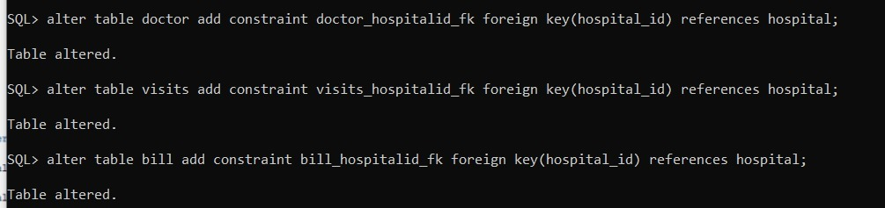

**Referencing to Doctor Table-1 constraint**

alter table perform_tests add constraint performs_tests_doctor_id_fk foreign key(doctor_id) references doctor;



**Referencing to Patient Table- 3 constraints**

alter table bill add constraint bill_p_id_fk foreign key(patient_id) references patient;

alter table perform_tests add constraint performs_test_p_id_fk foreign key(p_id) references patient;

alter table visits add constraint visits_p_id_fk foreign key(p_id) references patient;

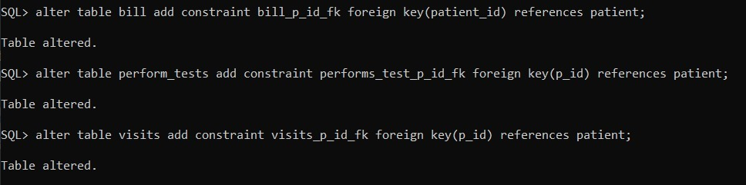

**Referencing to Medicine Table- 1 constraint**

alter table sells add constraint sells_medicine_name_fk foreign key (medicine_name) references medicine;



5 (b) Enter necessary sample data (at least two rows into each table) into the tables and display the content of each table.

**Inserting Values**

**1.HOSPITAL VALUES**

insert into hospital values ('AMD1','SHALBY HOSPITAL',6355411418,'Ahmedabad,Gujarat,India','www.shalbyamd.com');

insert into hospital values ('SUR1','AMBANI HOSPITAL',7355411418,'Surat,Gujarat,India','www.ambanisurat.com');

insert into hospital values ('AMD2','NARAYANI HOSPITAL',9355411418,'Ahmedabad,Gujarat,India','www.narayaniamd.com');

insert into hospital values ('AMD4','Sai HOSPITAL',46910650170,'Ahmedabad',null);

insert into hospital values ('SUR5','Appolo HOSPITAL',519289518,'Surat',null);

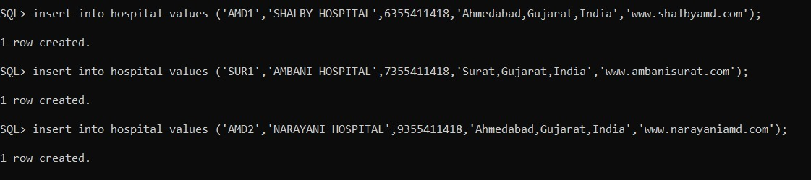

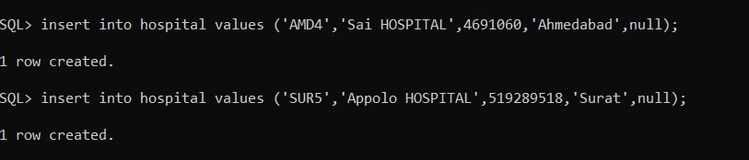

**Select * from hospital;**

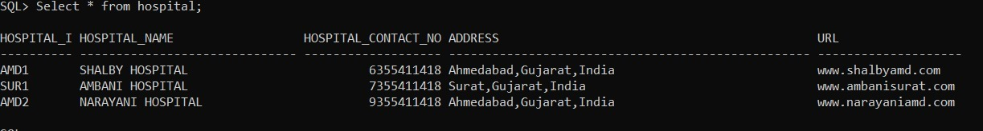

**SUPERITENDENT VALUES-**

insert into superitendent values(111,'AMD2','DEEP','RAJESH','GADHIYA',9785411418,'Ahemdabad,Gujarat,India','deep@gmail.com');

insert into superitendent values(112,'AMD1','AAYUSH','UPESH','PATEL',6485411418,'Ahemdabad,Gujarat,India','auc@gmail.com');

insert into superitendent values(113,'SUR1','JEVIN','MUKESH','VEKARIA',7785411418,'Surat,Gujarat,India','jevin@gmail.com');

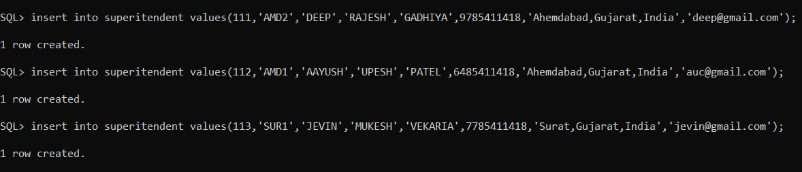

* **select * from superitendent;**

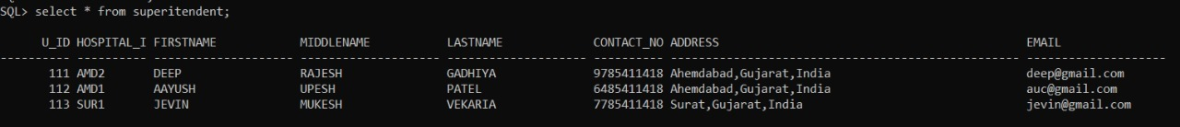

* **DOCTOR VALUES-**

insert into doctor values(123,'SURESH','MUKESH','PATEL',9992223450,'Dermatology','suresh@mail.com','Naroda,Ahemdabad,Gujarat,India',5000,'AMD1');

insert into doctor values(113,'RAMESH','MUKESH','SINGH',9702223450,'Dermatology','rahesh@mail.com','Naroda,Ahemdabad,Gujarat,India',1000,'AMD1');

insert into doctor values(114,'PROMIT','RAJ','REVAR',8702223450,'Neurology','promit@mail.com','Naroda,Ahemdabad,Gujarat,India',1200,'AMD1');

insert into doctor values(115,'DEEPIKA','MAHESH','PADUKONE',9902223450,'Cardiology','deepika@mail.com','Naroda,Ahemdabad,Gujarat,India',7000,'AMD1');

insert into doctor values(111,'SHAUNAK','RAKESH','DAVE',9792223450,'Pediatrics','shaunak@mail.com','Surat,Ahemdabad,Gujarat,India',5900,'SUR1');

insert into doctor values(121,'JAINAM','MANI','DESAI',8902223450,'Surgeon','jainam@mail.com','Surat,Gujarat,India,',6700,'SUR1');

insert into doctor values(123,'TOMAR','RAJ','SINGH',8702223450,'Neurology','promit@mail.com','Surat,Ahemdabad,Gujarat,India',9800,'SUR1');

insert into doctor values(124,'HEMANG','MAHESH','PALIWAL',9902223450,'Cardiology','deepika@mail.com','Surat,Ahemdabad,Gujarat,India',800,'SUR1');

insert into doctor values(211,'DHRUVIL','RAMESH','DAVE',9792223450,'Pediatrics','shaunak@mail.com','Surat,Ahemdabad,Gujarat,India',5900,'SUR1');

insert into doctor values(131,'NAWAZ','MUKESH','KHAN',9992223450,'Internal medicine','nawaz@mail.com','Gandinagar,Ahemdabad,Gujarat,India',5700,'AMD2');

insert into doctor values(132,'AZEEM','ULLHA','KHAN',9702223450,'Psychiatry','azeem@mail.com','Gandinagar,Ahemdabad,Gujarat,India',8900,'AMD2');

insert into doctor values(134,'KUNJ','RAJ','PATEL',8792223450,'Neurology','kunj@mail.com','Gandhinagar,Ahemdabad,Gujarat,India',5600,'AMD2');

insert into doctor values(135,'BHARAT','MAHESH','PADUKONE',9902223450,'Cardiology','bharat@mail.com','Gandhinagae,Ahemdabad,Gujarat,India',7700,'AMD2');

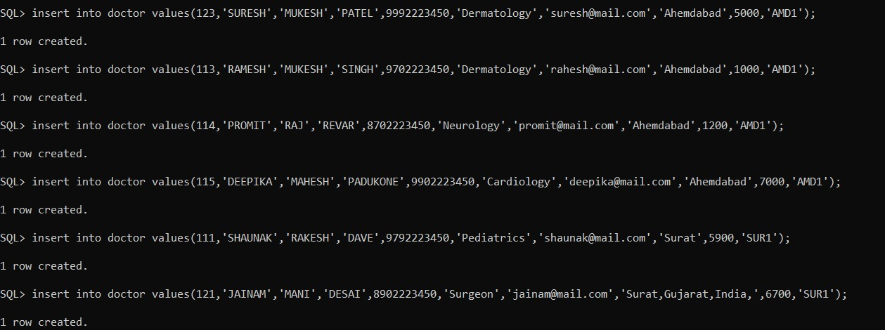

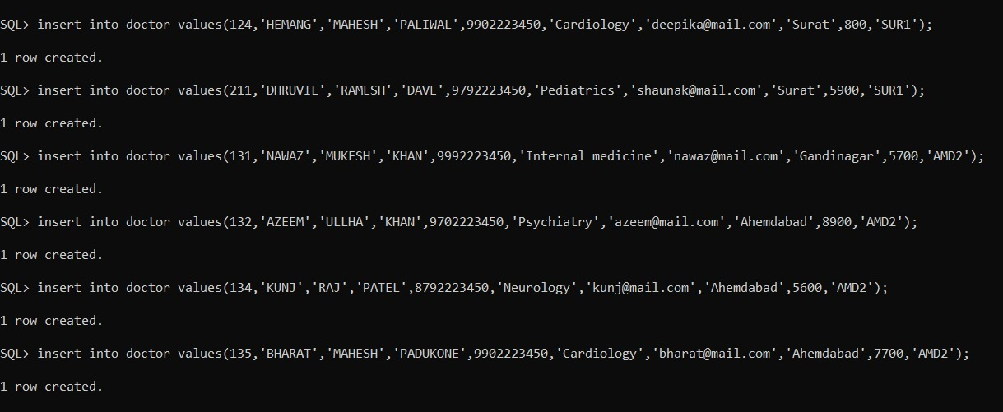

* **select * from doctor;**

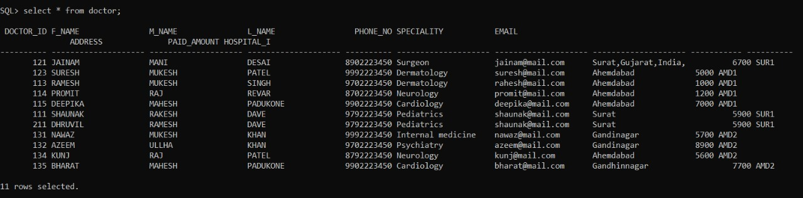

* **PATIENT VALUES-**

insert into patient values (102,'dinda','bharatbhai','pavalia',4756348752,'M', to_date('05/02/2020','dd/mm/yyyy'),'chennai,tamilnadu','AB+',7465492341,'ashok');

insert into patient values (103,'shubh','umeshbhai','savalia',7548576935,'M', to_date('30/04/2020','dd/mm/yyyy'),'amritsar,punjab','O+',4756382934,'sonali');

insert into patient values (104,'khushi','navanitbhai','talaviya',5739427495,'F', to_date('09/04/2020','dd/mm/yyyy'),'surat,gujarat','O+',8657435698,'diti');

insert into patient values (105,'diti','ritesh','vekaria',6748395769,'F', to_date('16/04/2020','dd/mm/yyyy'),'surat,gujarat','AB+',8437569103,'hetsi');

insert into patient values (106,'abhay','dilipbhai','parmar',5764835693,'M', to_date('08/10/2020','dd/mm/yyyy'),'Banglore,karnataka','B-',1234546784,'gajraj');

insert into patient values (107,'charvee','pragnesh','saraiya',5764835786,'M', to_date('2/4/2020','dd/mm/yyyy'),'surat','A+',1234546784,'dinu');

insert into patient values (108,'shobhit','palliwal','abc',5764835669,'M', to_date('12/10/2020','dd/mm/yyyy'),'bhopal','0-',1234546784,'pinu');

insert into patient values (109,'ankon','Nandi','xyz',5764835609,'M', to_date('10/10/2020','dd/mm/yyyy'),'Hyderabad','B+',1234546784,'jinu');

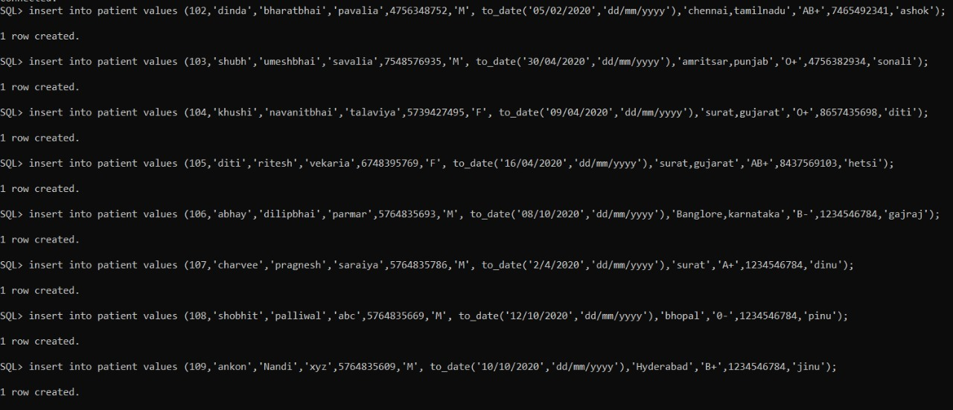

**select * from patient;**

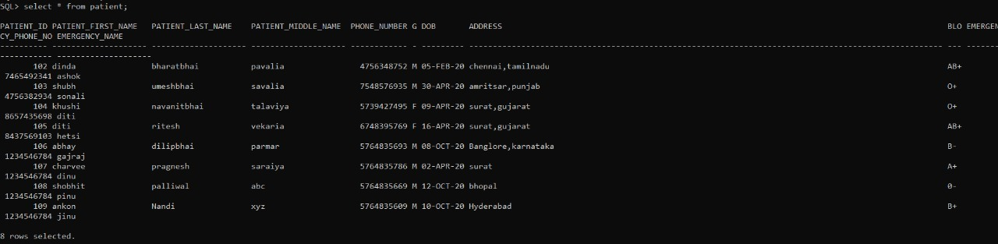

* **MEDICINE VALUES-**

insert into medicine values('Lexapro','Lupin Limited',4000,20);

insert into medicine values('Clonazepam','Cipla Limited',2000,98);

insert into medicine values('Otezla','Cadila Ltd',7200,25);

insert into medicine values('Januvia','AuroPharma',1000,77);

insert into medicine values('Entresto','Sun Limited',450,82);

insert into medicine values('Ativan','Cipla Limited',2100,17);

insert into medicine values('Crocin','Lupin Limited',100,200);

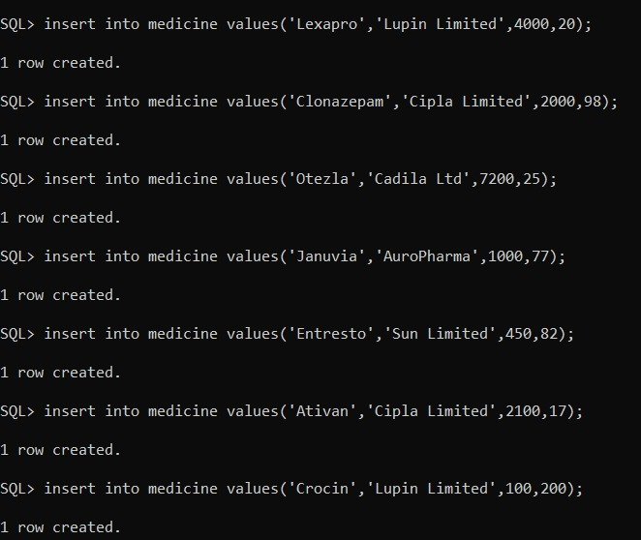

**select * from medicine;**

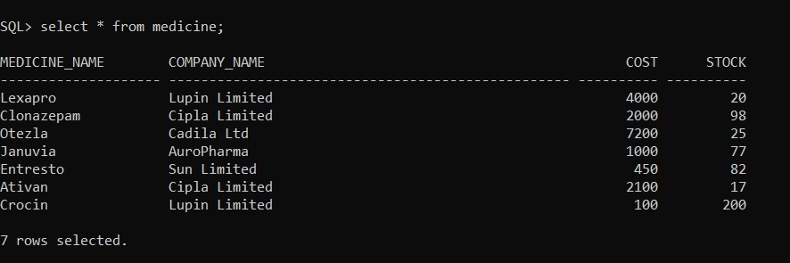

* **SELLS VALUES-**

insert into sells values('Crocin',12345);

insert into sells values('Ativan',12345);

insert into sells values('Otezla',12345);

insert into sells values('Januvia',12345);

insert into sells values('Crocin',123456);

insert into sells values('Lexapro',123456);

insert into sells values('Entresto',123456);

insert into sells values('Ativan',123456);

insert into sells values('Otezla',123456);

insert into sells values('Clonazepam',1234567);

insert into sells values('Januvia',1234567);

insert into sells values('Ativan',1234567);

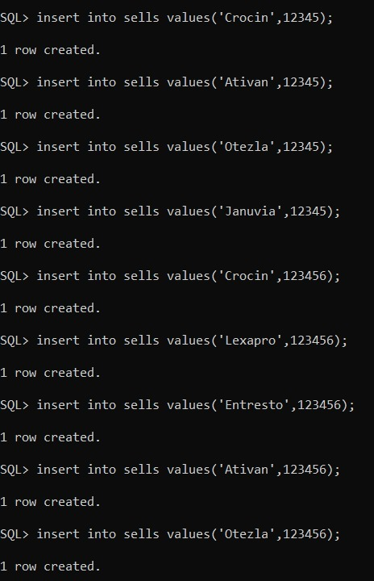

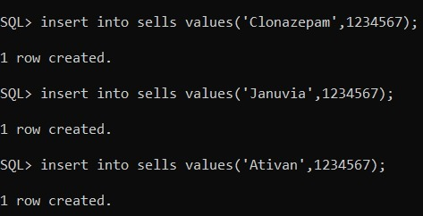

* **select * from sells;**

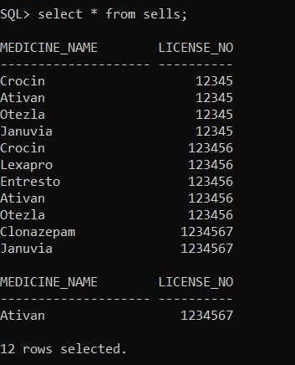

* **BILL VALUES-**

insert into bill values(123,3000,to_timestamp('10:30','hh24:mi'),to_date('09-07-2020','dd-mm-yyyy'),to_date('29-10-2020','dd-mm-yyyy'),5000,101,'AMD1');

insert into bill values(124,3500,to_timestamp('14:40','hh24:mi'),to_date('29-06-2020','dd-mm-yyyy'),to_date('19-10-2020','dd-mm-yyyy'),7000,102,'AMD1');

insert into bill values(125,4000,to_timestamp('19:30','hh24:mi'),to_date('06-02-2020','dd-mm-yyyy'),to_date('29-11-2020','dd-mm-yyyy'),5000,103,'AMD2');

insert into bill values(126,5390,to_timestamp('14:56','hh24:mi'),to_date('14-06-2020','dd-mm-yyyy'),to_date('09-12-2020','dd-mm-yyyy'),6500,104,'AMD2');

insert into bill values(127,4200,to_timestamp('23:10','hh24:mi'),to_date('22-04-2020','dd-mm-yyyy'),to_date('21-11-2020','dd-mm-yyyy'),10000,105,'SUR1');

insert into bill values(128,4300,to_timestamp('15:30','hh24:mi'),to_date('21-06-2020','dd-mm-yyyy'),to_date('24-10-2020','dd-mm-yyyy'),7500,106,'SUR1');

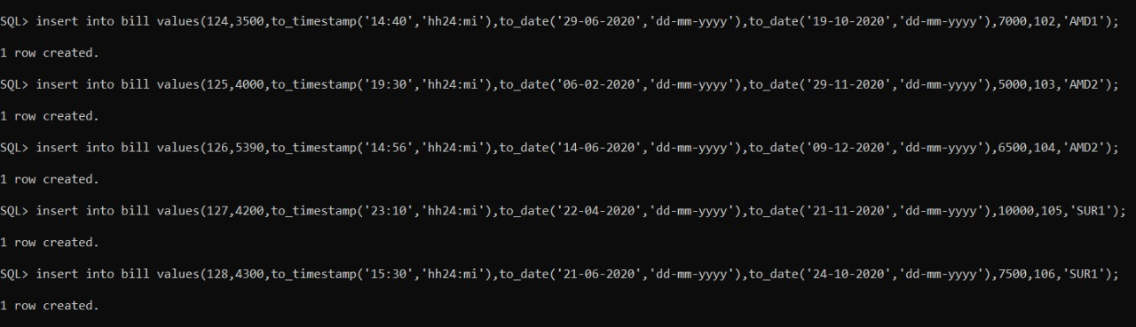

**select * from bill;**

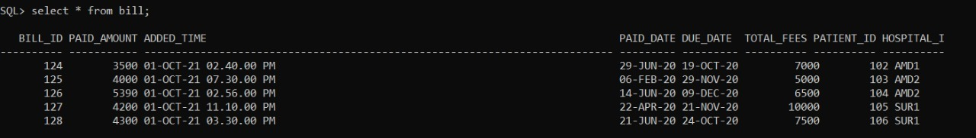

**VISIT VALUES-**

insert into visits values('AMD1',101,'high fever',to_date('09-07-2020','dd-mm-yyyy'),to_timestamp('10:40','hh24:mi'));

insert into visits values('AMD1',102,'vomiting',to_date('30-06-2020','dd-mm-yyyy'),to_timestamp('11:30','hh24:mi'));

insert into visits values('AMD2',103,'chicken pox',to_date('06-02-2020','dd-mm-yyyy'),to_timestamp('20:30','hh24:mi'));

insert into visits values('AMD2',104,'corona',to_date('18-06-2020','dd-mm-yyyy'),to_timestamp('16:00','hh24:mi'));

insert into visits values('SUR1',105,'brain damage',to_date('23-04-2020','dd-mm-yyyy'),to_timestamp('23:50','hh24:mi'));

insert into visits values('SUR1',106,'food poison',to_date('21-06-2020','dd-mm-yyyy'),to_timestamp('19:00','hh24:mi'));

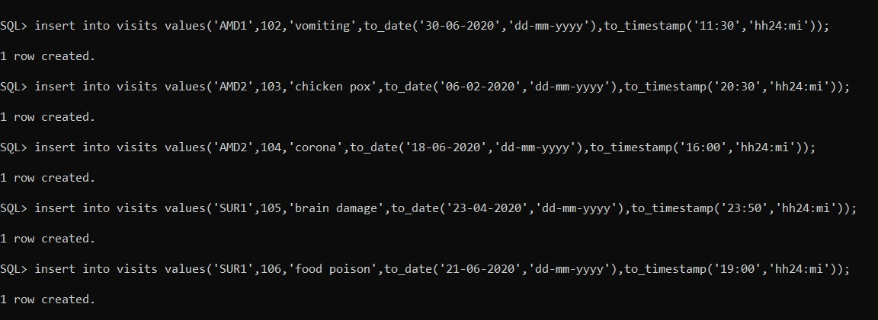

* **select * from visits;**

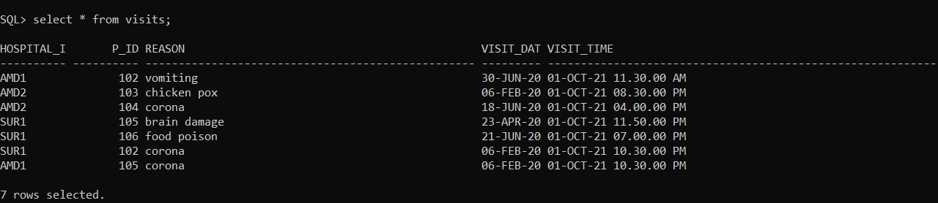

* **PERFORM TEST VALUES-**

insert into perform_tests values(101,114,'AMD1',500,'COVID TEST',to_date('09-07-2020','dd-mm-yyyy'),'Antibody');

insert into perform_tests values(103,131,'AMD2',550,'POLIO TEST',to_date('09-07-2020','dd-mm-yyyy'),'Antibody');

insert into perform_tests values(105,223,'AMD1',9000,'MRI SCAN',to_date('09-07-2020','dd-mm-yyyy'),'Full MRI');

insert into perform_tests values(106,121,'AMD1',780,'BLOOD TEST',to_date('21-06-2020','dd-mm-yyyy'),'CBC TEST');

insert into perform_tests values(104,131,'AMD2',3000,'FULL BODY',to_date('18-06-2020','dd-mm-yyyy'),'Full MRI');

insert into perform_tests values(102,115,'AMD1',750,'FULL BODY',to_date('1-07-2020','dd-mm-yyyy'),'Full MRI');

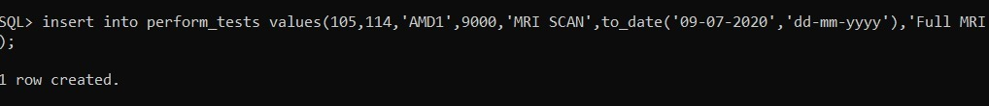

**select * from perform_tests;**

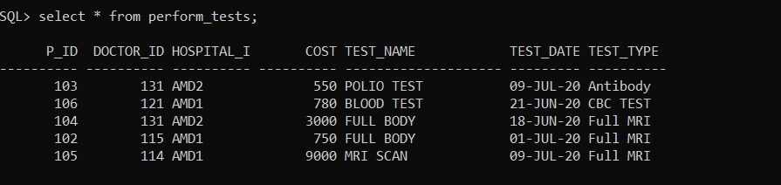

* **Write down the necessary SQL statements for implementation of functional requirements through SQL select, delete and update statement.**

1. **RETRIEVAL OF DATA:**
2. **1.Give hospital name and url . If url is null then show not present (nvl function):**

select hospital_name,nvl(url,'NOT PRESENT') "URL" from hospital;

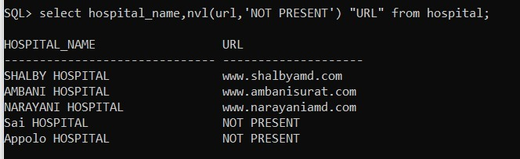

**2.Give hospital id,name and email of superitendents . If email is not given then put null (nullif function):**

Select hospital_id,firstname,middlename,nullif(email,'Null') "Email" from superitendent;

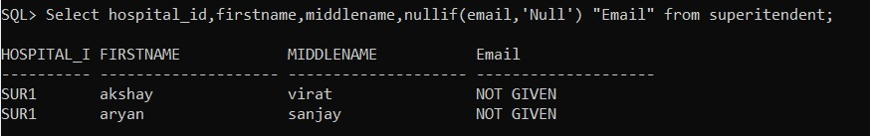

* **Find the name of patient from visits table and there visit reason from surat city( JOIN QUERY)-**

select v.hospital_id,p.patient_first_name,visit_date,reason,address from visits v inner join patient p on v.p_id=p.patient_id where address like 'surat%';



* **Find the name of patient from visits table and there visit reason from surat city(LEFT JOIN QUERY)-**

select v.hospital_id,p.patient_first_name,visit_date,reason,address from visits v left join patient p on v.p_id=p.patient_id where address like 'surat%';



* **Find hospital id, patient name, reason, address from patient table using left join-**

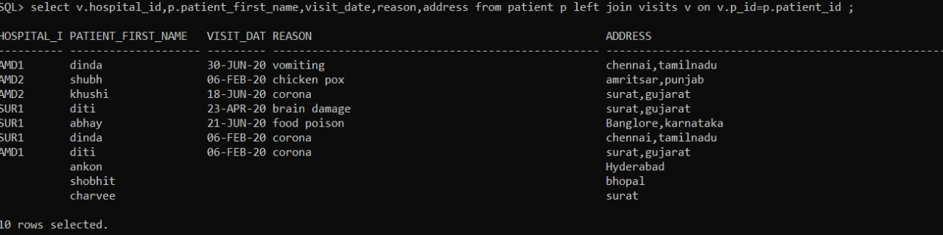

4.**Find doctor names who has average costs of tests on his patients >900 (uncorrelated nested query)**

select f_name,m_name,l_name from doctor where doctor_id in(select doctor_id from perform_tests group by doctor_id having avg(cost)>900);

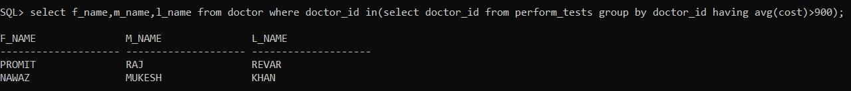

**DELETION OF DATA-**

* **delete from bill where paid_amount=total_fees;**

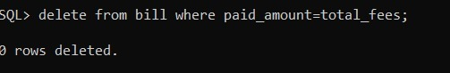

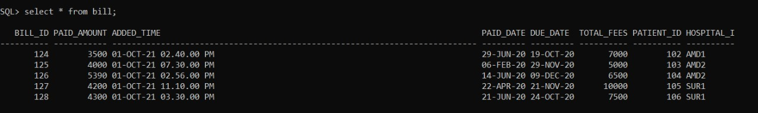

* **UPDATION OF DATA-**

**Q- Patient with patient id 105 paid 1000 RS amount for the treatment he**

**received so update that amount in his bill details.**

Update bill set paid_amount=paid_amount+1000 where patient_id=105;

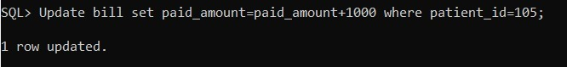

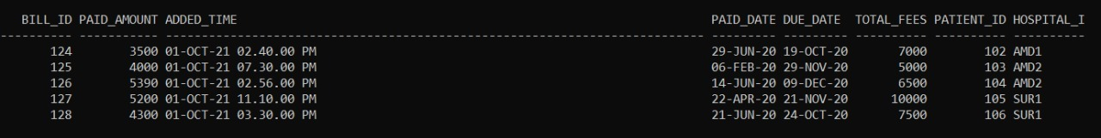

**Q- Add a new column to bill table which has due amount and update it**

alter table bill add due_amount number(10);

update bill set due_amount=total_fees-paid_amount;

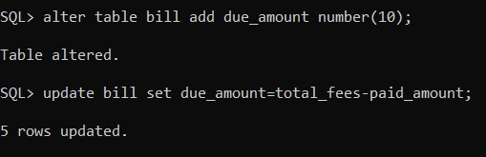

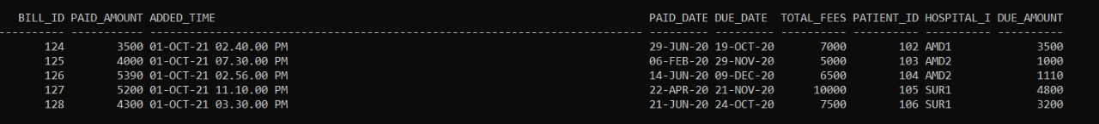

**Q- Give a discount of 100 RS in total fees to all patients having blood group of O+**

select * from patient where blood_group='O+';

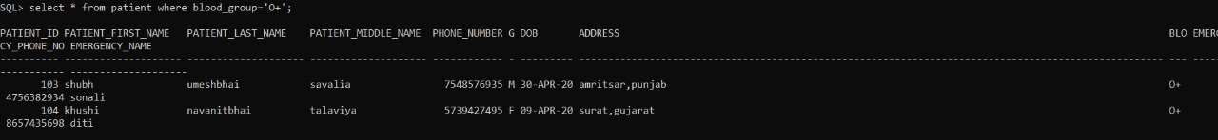

**NORMALISATION:**

**This database is already in 2 NF form.**